Texas Wranglers 4-H Club

Is hosting

“Down on the Farm”
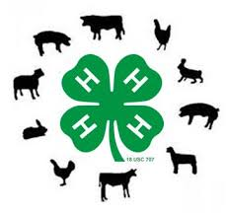

When: Sunday, October 8

Time: 2pm-4pm

Location: Ride With Pride, 480 W. Highland Street, Southlake

This is an exciting event that provides children with special needs the opportunity to interact with farm animals and play games.

Hope to see you there!

www.ridewithprideinc.com
www.amyswishwithwings.com

